**EMPLOYEE DEPARTMENT ANALYSIS**

1. Create the Employee Table as per the Below Data Provided

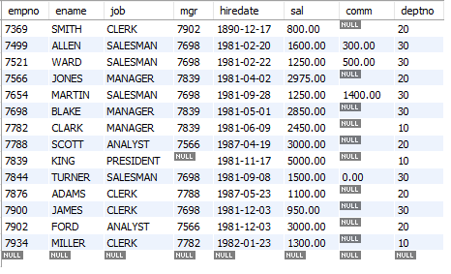

**Note:** Ensure the Salary cannot be Less then Negative or Zero

Deptno Should be foreign key. Referring to the Dept, dept Table created in Step 2

Empno cannot be null or Duplicate.

Default Job should be Clerk

1. Create the Dept Table as below

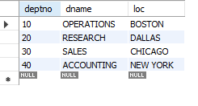

1. List the Names and salary of the employee whose salary is greater than 1000
2. List the details of the employees who have joined before end of September 81.
3. List Employee Names having I as second character.
4. List Employee Name, Salary, Allowances (40% of Sal), P.F. (10 % of Sal) and Net Salary. Also assign the alias name for the columns
5. List Employee Names with designations who does not report to anybody
6. List Empno, Ename and Salary in the ascending order of salary.
7. How many jobs are available in the Organization?
8. Determine total payable salary of salesman category
9. List average monthly salary for each job within each department
10. Use the Same EMP and DEPT table used in the Case study to Display EMPNAME, SALARY and DEPTNAME in which the employee is working.
11. Create the Job Grades Table as below

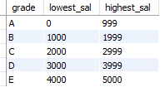

1. Display the last name, salary and Corresponding Grade.
2. Display the Emp name and the Manager name under whom the Employee works in the below format.

**Emp Report to Mgr**.

1. Display Empname and Total sal where Total Sal (sal + Comm)
2. Display Empname and Sal whose Empno is an odd number
3. Display Empname, Rank of sal in Organisation, Rank of Sal in their department
4. Display Top 3 Empname based on their Salary
5. Display Empname who has highest Salary in Each Department.

**ORDERS, CUST, SALESPEOPLE**

1. Create the Salespeople as below screenshot.

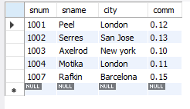

1. Create the Cust Table as below Screenshot 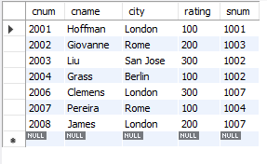
2. Create orders table as below screenshot.

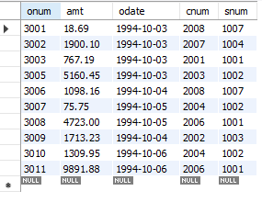

1. Write a query to match the salespeople to the customers according to the city they are living.
2. Write a query to select the names of customers and the salespersons who are providing service to them.
3. Write a query to find out all orders by customers not located in the same cities as that of their salespeople
4. Write a query that lists each order number followed by name of customer who made that order
5. Write a query that finds all pairs of customers having the same rating………………
6. Write a query to find out all pairs of customers served by a single salesperson………………...
7. Write a query that produces all pairs of salespeople who are living in same city………………...
8. Write a Query to find all orders credited to the same salesperson who services Customer 2008
9. Write a Query to find out all orders that are greater than the average for Oct 4th
10. Write a Query to find all orders attributed to salespeople in London.
11. Write a query to find all the customers whose cnum is 1000 above the snum of Serres.
12. Write a query to count customers with ratings above San Jose’s average rating.
13. Write a query to show each salesperson with multiple customers.